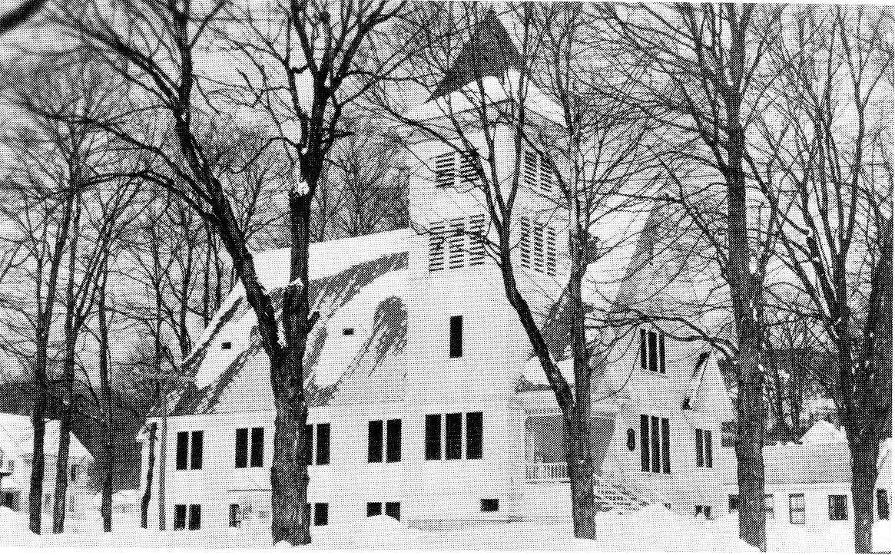

“Our Town”

Our town of Bartlett, a little village tucked away in the heart of the White Mountains, has not changed much in the last fifteen or twenty years. This school year, however, we have seen many changes in the two schools in our town. The younger students were fortunate enough to be presented with a new grammar school. Also, we high school students have seen many improvements in our school. We have a new lighting system, a new heating system, and also have seen many improvements made in our gymnasium.
Mr. Manna and some of the boys were generous enough to use their leisure time to builds us a skating rink. The rink has been enjoyed very much, and we, the students of Bartlett High School, with to thank Mr. Manna and his helpers for their contribution to our recreational facilities.
This school year also found us one teacher short. Last year the school started a commercial course which consisted of typing, and a course in shorthand. The fact that we were minus one teacher cost us many of our fellow students. They have gone to different schools where they enjoy greater academic opportunities. The rest of us are trying to make the best of our opportunities here. We hope that next year we will be able to extend our curriculum to include other subjects.
After much thought and deliberation we decided to dedicate this volume of the Shield to our mothers and fathers, who have always been nearby to give us a helping hand when it was needed. We hope that our parents will accept this volume of the Shield as a token of our appreciation.

Sincerely,
The Seniors of Bartlett High School 1958
